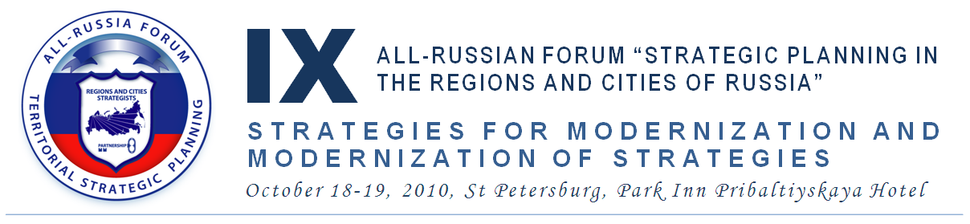

INFORMATION FOR SPEAKERS AND AUTHORS

THE PUBLICATION OF REPORTS
1. Each registered participant can submit a report related to the Forum topic (no more than 20 000 characters) till November, 30th, 2010
Reports should be submitted in electronic form in the name of the Forum scientific adviser Boris Zhikharevich and sent to citystrategy@leontief.ru in the Word or PDF format.
Alongside with the report it is necessary to send an abstract of the report (1000 characters maximum) in the Word format.
2. All the reports received before the indicated period will be published on the Forum site in author's edition in the PDF format within 3 working days after the receipt.
3. The reports received up to and including October, 13th, 2010, are located on CD's (USB flash drives) and included into the participant's complete pack in PDF format.
Abstracts of the reports (including the contact information at author’s will) are located in a selection of abstracts, published in paper and included into the participant's pack.
4. Reports for the paper publication in the Forum Digest are selected by editorial group after the Forum. Authors of the selected reports can finish the reports and send them for the publication in the Digest up to November, 30th, 2010. Reports for the Digest are sent in the Word format and undergo editorial process.
Approximate date of Forum Digest publication – February, 2011

REPORTS AT THE FORUM
Each registered participant can apply for making a report or presentation at one of Forum events. All applications, including an abstract of the report should be submitted during the registration (log-in) procedure or soon after, but not later than October, 5th, 2010 and should be addressed in the name of the Forum scientific adviser to citystrategy@leontief.ru or to a moderator of a specific round table.
The decision on the inclusion of the report in the Forum program is accepted by the Organizing committee on the basis of the abstract (or full text of the report) on the Forum Working group submission and by agreement with the responsible organizer and a moderator of a specific round table.
The preference will be given to the reports closest to the topic of a specific round table and submitted before the rest.
The speakers of plenary session are invited by Organizing Committee in person.

